Alexander Lizzo December 4, 2019

Database Management | CMPT 308 Professor Thomas McKee

**FINAL PROJECT**

(To be presented for extra credit)

For my final project in *Database Management*, I created a relational database with the ability to track physician fees and hours based on contractual agreements. My idea stemmed from my full-time employment as a Revenue and Reimbursement Specialist at Nuvance Health (formerly known as Health-Quest Systems). I closely monitor the timesheet expense of, and hours of work performed by hundreds of internal, external, and graduate medical education physicians within the healthcare network. My final project streamlines this process and ultimately creates and maintains an accurate repository of information for myself and my colleagues. Below is a summary of my experience developing the relational database while incorporating the content presented in this course.

My first draft of the entity relational diagram detailed reports instead of entities. Additionally, I placed several similar (and repetitive) data within one single entity. I soon realized that most of the entities I modeled were superfluous, and several of them later became attributes of others. Likewise, I combined entities I initially thought to be separate. For example, and as depicted below, instead of querying the information I need together, I tried to create it all in one place. I ultimately filtered the information and condensed the diagram to avoid excessive time consumption in loading the data.

As I progressed in the course and learned new material, I applied fundamental concepts to the final project. Following the instruction of chapter 2 of *Modern Relational Databases*, and on modeling ERDs, I revisited my diagram to express slight variations of similar entities. I paid special attention to the unique impact of each variation on the overall structure. This proved to be challenging and my first attempt at relating different types of doctors took the visual form of a spider web, negatively complicating the flow of logic. The image below depicts this failed attempt.

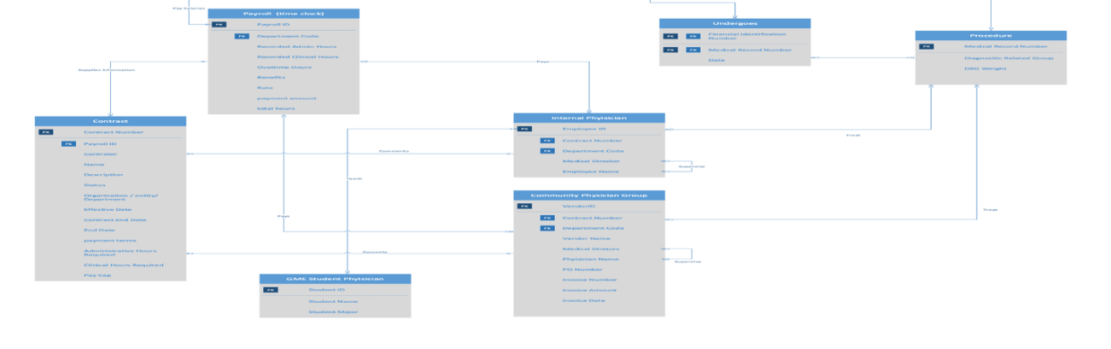

Only after learning about the overlapping super types and subtypes presented in chapter 3 —Enhances Entity Relational Diagram — did I streamline the relationships into a neat supertype/subtype hierarchy, while preserving the essential role and influence of each data point. The image below depicts this subsequent level of cleanup of the relational diagram.

Chapter 4’s focus on the normalization of the data and its relations proved especially helpful and enlightening. The normalization process reduced the amount of redundancy within the entities of my ERD. Furthermore, differentiating the partial and transient dependencies made it easier to sort the data and identify referential integrity constraints between the primary and foreign keys among entities.

The process of separating the data into the third normal form also simplified writing code. I did not have to reinvent the wheel and start the code from scratch. In MySQL Workbench, if a foreign key is written prior to a primary key, then an error occurs. The use of the relation schema helped to reduce errors when writing tables of the database.

Following the creation of the logical schema, I quickly recognized unnecessary tables and removed them to produce a straightforward relation within the database. Finally, decisions of the tables in the database were largely based on the relation schema or error messages within the database system. Once the database was set up and its tables contained the necessary information, it became easy to query.

Throughout my final project, my data ultimately became easier to manipulate and my understanding of the end goal of my relational database became clearer. I attribute these successes to the live application of the course content to my relational database. With each newfound knowledge, I became equipped to tailor the database to its final product.

*Please note, that should my time permit this semester, I would like to explore how the tables in my relational database will interact with a local front-end web project using middleware known as PHP-MY-ADMIN.*